International Messaging
One of the most requested features for KDE Connect is the ability to send SMS from the desktop. We already support this to a certain degree with the ability to reply to a message, and some people have set up Kontact to be able to send via KDE Connect, but both of those are annoying to use since they don’t have the conversation history. And it’s not that we don’t know it could be better, but for most of the long-time developers of KDE Connect, sending SMS to test any improvements costs serious money!
But now let me introduce myself. I am Simon, I grew up in the Southwestern United States, and I am about to finish my Bachelor’s in Computer Science and begin work on my Masters. But most importantly, I have an unlimited SMS plan.
Since KDE Connect already has the ability to send a new SMS given a phone number, my first plan of action was to figure out some way to get a user’s contacts book from the device to the desktop. Before meeting in Barcelona, I had submitted a few attempts to make this work. My initial thoughts were overly complicated, but gave me good experience with the Android side of how to read the contact’s database, and with dbus. When we all finally were able to meet in the same room and discuss which direction this contacts plugin should take – another often-requested feature of KDE Connect is the ability to synchronize contacts with the desktop, which we aren’t aiming to support today, but which we didn’t want to rule out – Aleix suggested using KPeople, a KDE Framework for supporting a contacts database, which already has support for VCards. Android provides a handy, mostly feature-complete way to export contacts as VCard. All that remained to be done was hook the two together.
Long story short, after discovering that the Android interface was not as easy-to-use as it appeared to be, KDE Connect is now able to ship a pile of VCards to the desktop, where they are kept synchronized by checking Android’s modification timestamp.
Aleix then put together a quick GUI using QML and KPeople, and we were able to click on a contact’s name and send a message!
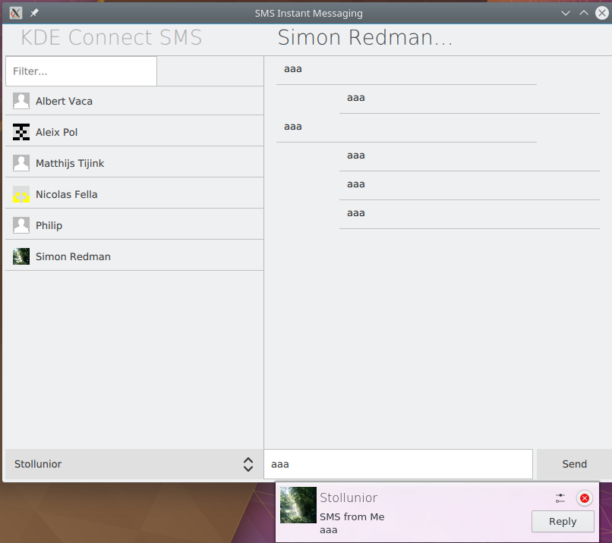
The next step is to build some way for KDE Connect to request the message history from the device. I am about half way through with this, and I hope to make significant progress as soon as the semester ends!

